NEWSLETTER

AMARTHYA SEN

**Amartya Kumar Sen** (Bengali pronunciation: [[ˈɔmortːo ˈʃen]](https://en.wikipedia.org/wiki/Help:IPA/Bengali); born 3 November 1933) is an Indian economist and philosopher. Sen has taught and worked in England and the United States since 1972. In 1998, Sen received the [Nobel Memorial Prize in Economic Sciences](https://en.wikipedia.org/wiki/Nobel_Memorial_Prize_in_Economic_Sciences) for his contributions to [welfare economics](https://en.wikipedia.org/wiki/Welfare_economics).[[6]](https://en.wikipedia.org/wiki/Amartya_Sen#cite_note-6) He has also made major scholarly contributions to [social choice theory](https://en.wikipedia.org/wiki/Social_choice_theory), [economic](https://en.wikipedia.org/wiki/Economic_justice) and [social justice](https://en.wikipedia.org/wiki/Social_justice), economic theories of [famines](https://en.wikipedia.org/wiki/Famine), [decision theory](https://en.wikipedia.org/wiki/Decision_theory), [development economics](https://en.wikipedia.org/wiki/Development_economics), [public health](https://en.wikipedia.org/wiki/Public_health), and the measures of [well-being](https://en.wikipedia.org/wiki/Well-being) of countries.

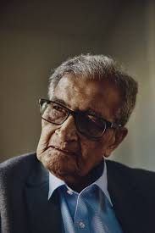

Early life and Education

Amartya Sen was born on 3 November 1933 in a [Bengali](https://en.wikipedia.org/wiki/Bengalis)[[9]](https://en.wikipedia.org/wiki/Amartya_Sen#cite_note-9)[[10]](https://en.wikipedia.org/wiki/Amartya_Sen#cite_note-10)[[11]](https://en.wikipedia.org/wiki/Amartya_Sen#cite_note-11)[[12]](https://en.wikipedia.org/wiki/Amartya_Sen#cite_note-12)[[13]](https://en.wikipedia.org/wiki/Amartya_Sen#cite_note-13)[[14]](https://en.wikipedia.org/wiki/Amartya_Sen#cite_note-14) family in [Santiniketan](https://en.wikipedia.org/wiki/Santiniketan), Bengal, British India. The first Asian to win a Nobel Prize,[[15]](https://en.wikipedia.org/wiki/Amartya_Sen#cite_note-15) the polymath and writer [Rabindranath Tagore](https://en.wikipedia.org/wiki/Rabindranath_Tagore), gave Amartya Sen his name ([Bengali](https://en.wikipedia.org/wiki/Bengali_language): অমর্ত্য, [romanized](https://en.wikipedia.org/wiki/Romanization_of_Bengali): *ômorto*, lit. 'immortal or heavenly').[[16]](https://en.wikipedia.org/wiki/Amartya_Sen#cite_note-16)[[17]](https://en.wikipedia.org/wiki/Amartya_Sen#cite_note-17) Sen's family was from Wari and [Manikganj](https://en.wikipedia.org/wiki/Manikganj_District), [Dhaka](https://en.wikipedia.org/wiki/Dhaka), both in present-day [Bangladesh](https://en.wikipedia.org/wiki/Bangladesh). His father, Ashutosh Sen, was a Professor of Chemistry at [Dhaka University](https://en.wikipedia.org/wiki/Dhaka_University), then the Development Commissioner in Delhi and then Chairman of the West Bengal Public Service Commission. Sen moved with his family to [West Bengal](https://en.wikipedia.org/wiki/West_Bengal) in 1945. Sen's mother, Amita Sen, was the daughter of [Kshiti Mohan Sen](https://en.wikipedia.org/wiki/Kshitimohan_Sen), the eminent Sanskritist and scholar of ancient and medieval India. Sen's maternal grandfather was a close associate of Tagore. K. M. Sen served as the second [Vice-Chancellor](https://en.wikipedia.org/wiki/Vice-Chancellor) of [Visva Bharati University](https://en.wikipedia.org/wiki/Visva-Bharati_University) from 1953 to 1954.

Amartya Sen was born on 3 November 1933 in a [Bengali](https://en.wikipedia.org/wiki/Bengalis)[[9]](https://en.wikipedia.org/wiki/Amartya_Sen#cite_note-9)[[10]](https://en.wikipedia.org/wiki/Amartya_Sen#cite_note-10)[[11]](https://en.wikipedia.org/wiki/Amartya_Sen#cite_note-11)[[12]](https://en.wikipedia.org/wiki/Amartya_Sen#cite_note-12)[[13]](https://en.wikipedia.org/wiki/Amartya_Sen#cite_note-13)[[14]](https://en.wikipedia.org/wiki/Amartya_Sen#cite_note-14) family in [Santiniketan](https://en.wikipedia.org/wiki/Santiniketan), Bengal, British India. The first Asian to win a Nobel Prize,[[15]](https://en.wikipedia.org/wiki/Amartya_Sen#cite_note-15) the polymath and writer [Rabindranath Tagore](https://en.wikipedia.org/wiki/Rabindranath_Tagore), gave Amartya Sen his name ([Bengali](https://en.wikipedia.org/wiki/Bengali_language): অমর্ত্য, [romanized](https://en.wikipedia.org/wiki/Romanization_of_Bengali): *ômorto*, lit. 'immortal or heavenly'). Sen's family was from Wari and [Manikganj](https://en.wikipedia.org/wiki/Manikganj_District), [Dhaka](https://en.wikipedia.org/wiki/Dhaka), both in present-day [Bangladesh](https://en.wikipedia.org/wiki/Bangladesh). His father, Ashutosh Sen, was a Professor of Chemistry at [Dhaka University](https://en.wikipedia.org/wiki/Dhaka_University), then the Development Commissioner in Delhi and then Chairman of the West Bengal Public Service Commission. Sen moved with his family to [West Bengal](https://en.wikipedia.org/wiki/West_Bengal) in 1945. Sen's mother, Amita Sen, was the daughter of [Kshiti Mohan Sen](https://en.wikipedia.org/wiki/Kshitimohan_Sen), the eminent Sanskritist and scholar of ancient and medieval India. Sen's maternal grandfather was a close associate of Tagore. K. M. Sen served as the second [Vice-Chancellor](https://en.wikipedia.org/wiki/Vice-Chancellor) of [Visva Bharati University](https://en.wikipedia.org/wiki/Visva-Bharati_University) from 1953 to 1954.

Meanwhile, Sen was elected to a Prize Fellowship at Trinity College, which gave him four years to study any subject; he made the decision to study [philosophy](https://en.wikipedia.org/wiki/Philosophy). Sen explained: "The broadening of my studies into philosophy was important for me not just because some of my main areas of interest in economics relate quite closely to philosophical disciplines (for example, [social choice theory](https://en.wikipedia.org/wiki/Social_choice_theory) makes intense use of [mathematical logic](https://en.wikipedia.org/wiki/Mathematical_logic) and also draws on [moral philosophy](https://en.wikipedia.org/wiki/Moral_philosophy), and so does the study of inequality and deprivation), but also because I found philosophical studies very rewarding on their own."[[23]](https://en.wikipedia.org/wiki/Amartya_Sen#cite_note-Philosophy-23) His interest in philosophy, however, dates back to his college days at Presidency, where he read books on philosophy and debated philosophical themes. One of the books he was most interested in was [Kenneth Arrow](https://en.wikipedia.org/wiki/Kenneth_Arrow)'s [*Social Choice and Individual Values*](https://en.wikipedia.org/wiki/Social_Choice_and_Individual_Values).

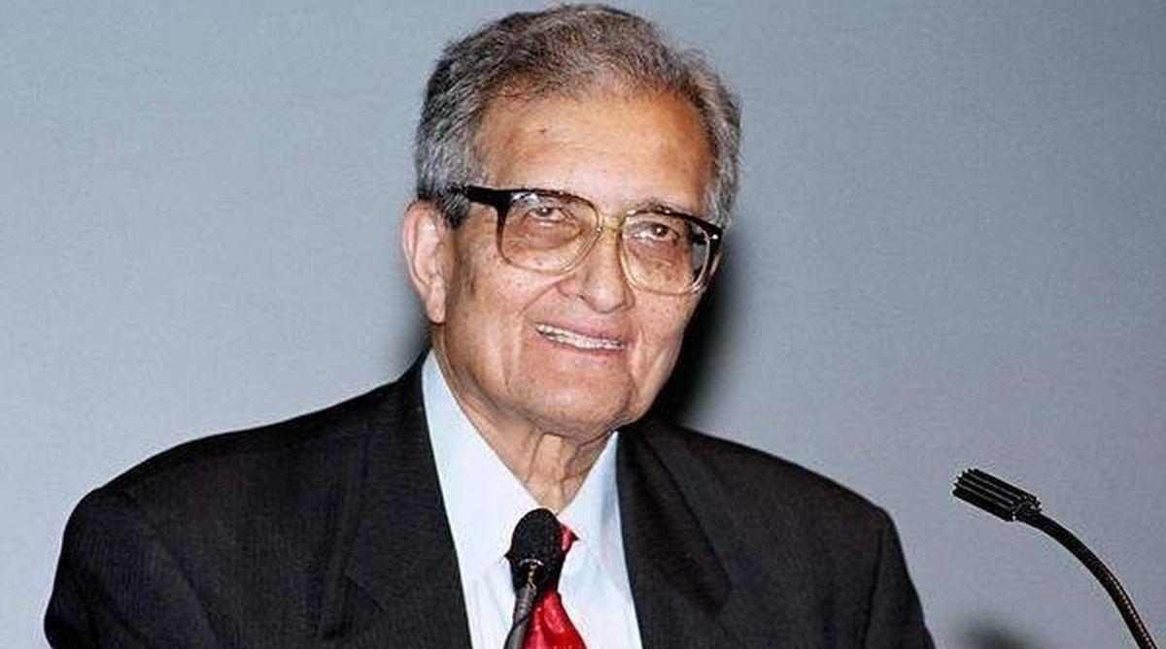

In Cambridge, there were major debates between supporters of [Keynesian economics](https://en.wikipedia.org/wiki/Keynesian_economics), and the neo-classical economists who were sceptical of Keynes. Because of a lack of enthusiasm for social choice theory in both Trinity and Cambridge, Sen chose a different subject for his [PhD](https://en.wikipedia.org/wiki/Doctor_of_Philosophy) thesis, which was on "[The Choice of Techniques](https://en.wikipedia.org/wiki/Choice_of_techniques)" in 1959. The work had been completed earlier, except for advice from his adjunct supervisor in India, [A. K. Dasgupta](https://en.wikipedia.org/wiki/A._K._Dasgupta), given to Sen while teaching and revising his work at Jadavpur, under the supervision of the "brilliant but vigorously intolerant" [post-Keynesian](https://en.wikipedia.org/wiki/Post-Keynesian) [Joan Robinson](https://en.wikipedia.org/wiki/Joan_Robinson).[[25]](https://en.wikipedia.org/wiki/Amartya_Sen#cite_note-Robinson-25) [Quentin Skinner](https://en.wikipedia.org/wiki/Quentin_Skinner) notes that Sen was a member of the secret society [Cambridge Apostles](https://en.wikipedia.org/wiki/Cambridge_Apostles) during his time at Cambridge.

Research work

**Social Choice Theory**

Sen's work on 'Choice of Techniques' complemented that of [Maurice Dobb](https://en.wikipedia.org/wiki/Maurice_Dobb). In a developing country, the Dobb-Sen strategy relied on maximising investible surpluses, maintaining constant real wages and using the entire increase in labour productivity, due to technological change, to raise the rate of accumulation. In other words, workers were expected to demand no improvement in their standard of living despite having become more productive. Sen's papers in the late 1960s and early 1970s helped develop the theory of [social choice](https://en.wikipedia.org/wiki/Social_choice), which first came to prominence in the work by the American economist [Kenneth Arrow](https://en.wikipedia.org/wiki/Kenneth_Arrow). Arrow had most famously shown that when voters have three or more distinct alternatives (options), any [ranked order](https://en.wikipedia.org/wiki/Ranked_voting_system) [voting system](https://en.wikipedia.org/wiki/Voting_system) will in at least some situations inevitably conflict with what many assume to be basic democratic norms. Sen's contribution to the literature was to show under what conditions [Arrow's impossibility theorem](https://en.wikipedia.org/wiki/Arrow%27s_impossibility_theorem)[[28]](https://en.wikipedia.org/wiki/Amartya_Sen#cite_note-28) applied, as well as to extend and enrich the theory of social choice, informed by his interests in [history of economic thought](https://en.wikipedia.org/wiki/History_of_economic_thought) and philosophy.

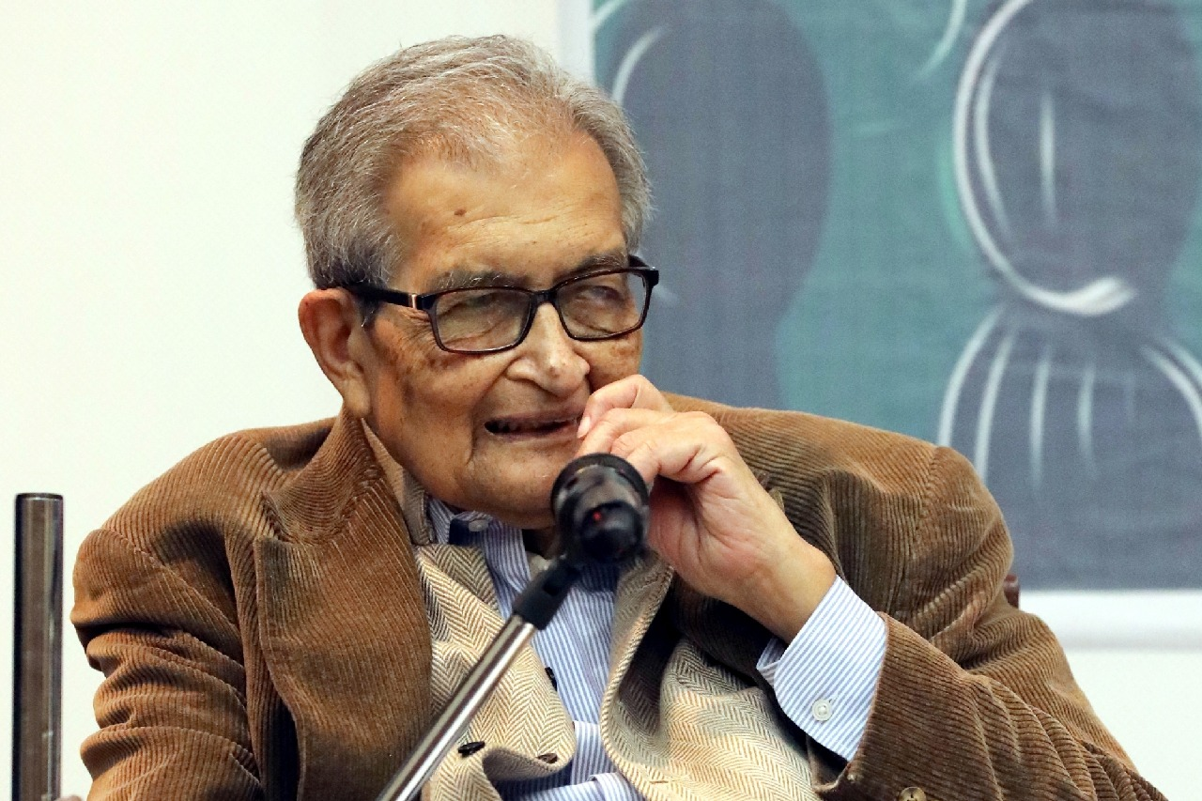

### Poverty and Famines

In 1981, Sen published *Poverty and Famines: An Essay on Entitlement and Deprivation* (1981), a book in which he argued that famine occurs not only from a lack of food, but from inequalities built into mechanisms for distributing food. Sen also argued that the Bengal famine was caused by an urban economic boom that raised [food prices](https://en.wikipedia.org/wiki/Food_prices), thereby causing millions of rural workers to starve to death when their wages did not keep up.[[29]](https://en.wikipedia.org/wiki/Amartya_Sen#cite_note-Time-29) In 1999 he wrote, "no famine has ever taken place ... in a functioning democracy".[[30]](https://en.wikipedia.org/wiki/Amartya_Sen#cite_note-30)

In addition to his important work on the causes of famines, Sen's work in the field of development economics has had considerable influence in the formulation of the "[Human Development Report](https://en.wikipedia.org/wiki/Human_Development_Report)",[[31]](https://en.wikipedia.org/wiki/Amartya_Sen#cite_note-UNDP-31) published by the [United Nations Development Programme](https://en.wikipedia.org/wiki/United_Nations_Development_Programme).[[32]](https://en.wikipedia.org/wiki/Amartya_Sen#cite_note-32) This annual publication that ranks countries on a variety of economic and social indicators owes much to the contributions by Sen among other social choice theorists in the area of economic measurement of poverty and inequality.